Task#1:
- Write a program that takes salary as input. Using conditional statements, calculate the final tax based on the following rules: (Marks 3) • If the salary is less than 30,000 → Tax rate is 5% • If the salary is between 30,000 and 70,000 → Tax rate is 15% • If the salary is greater than 70,000 → Tax rate is 25%
Answer:
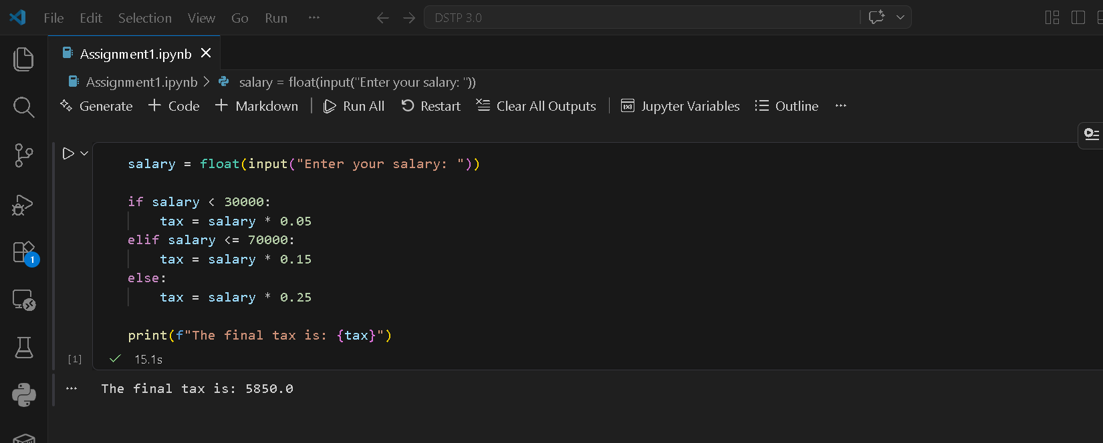

Task#2:
- Given a list of words: words = ["apple", "banana", "kiwi", "cherry", "mango"] (Marks 3) Create a dictionary that maps each word to its corresponding length. Example Output: ({"apple": 5, "banana": 6, "kiwi": 4, "cherry": 6, "mango": 5})
Answer:
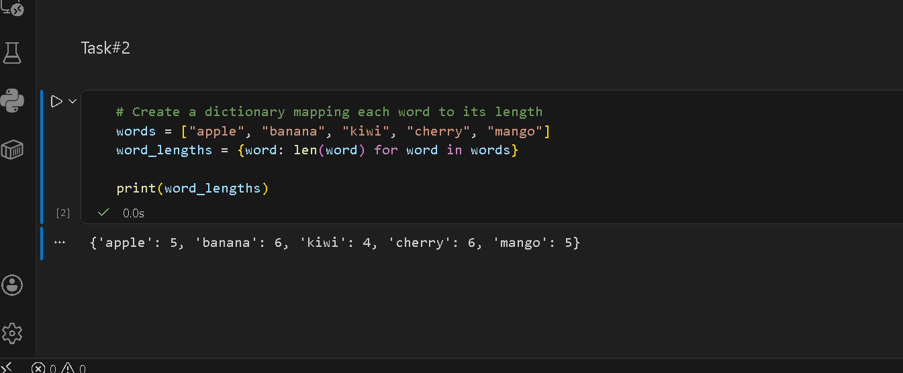
Task#3 Chat Room(OOP)
Answer:
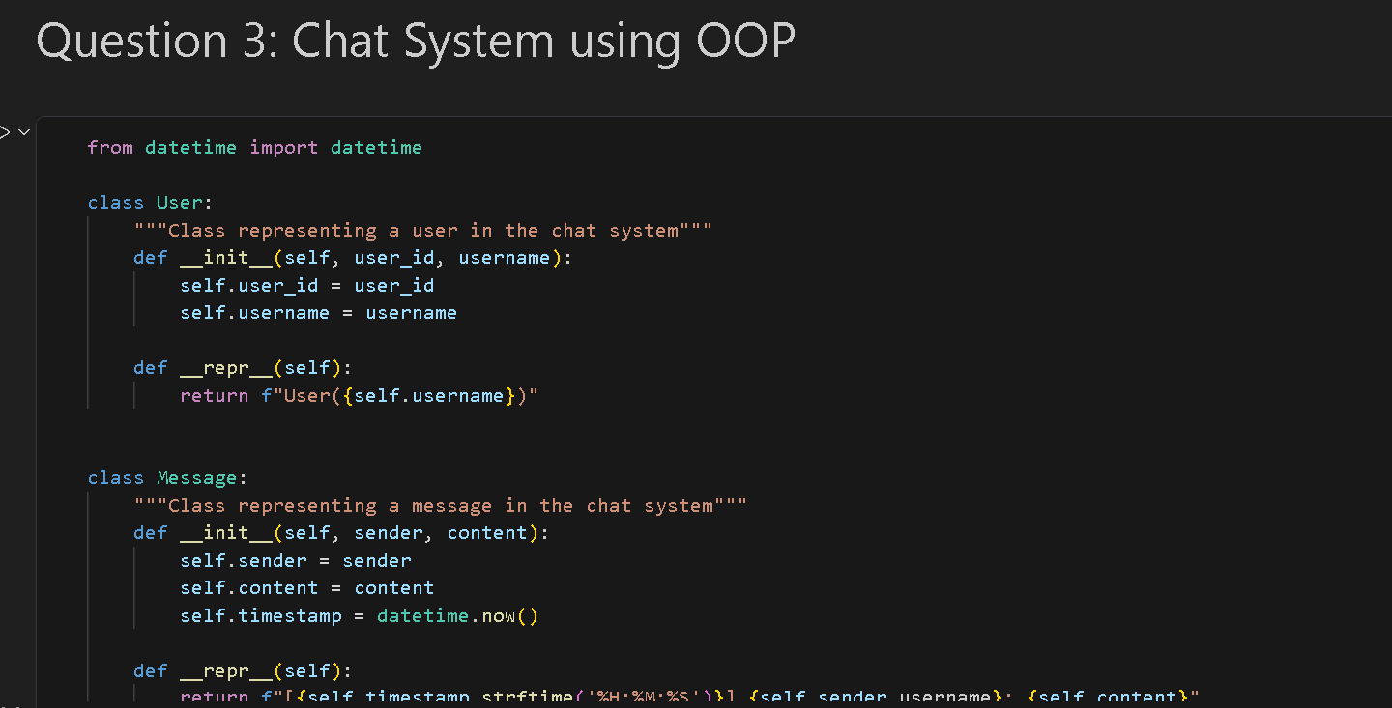

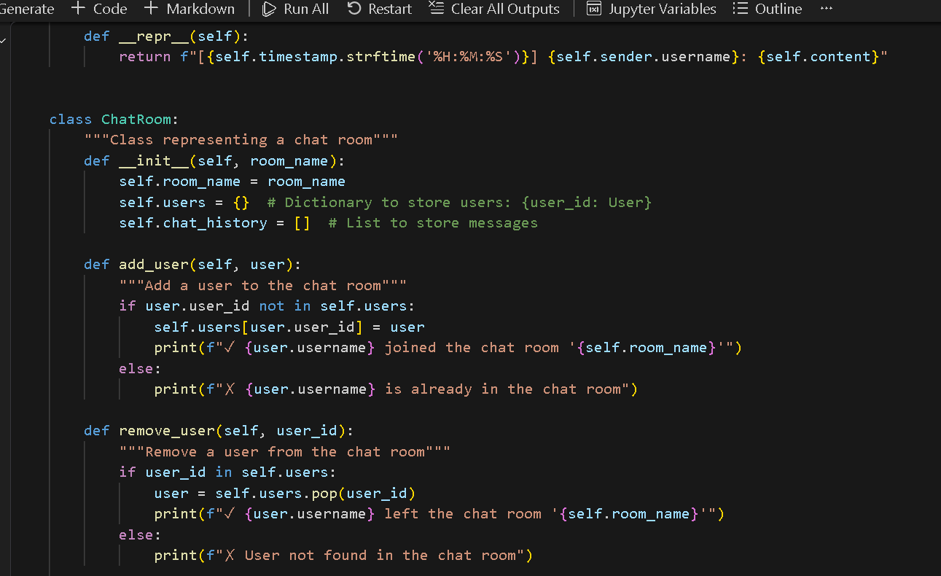

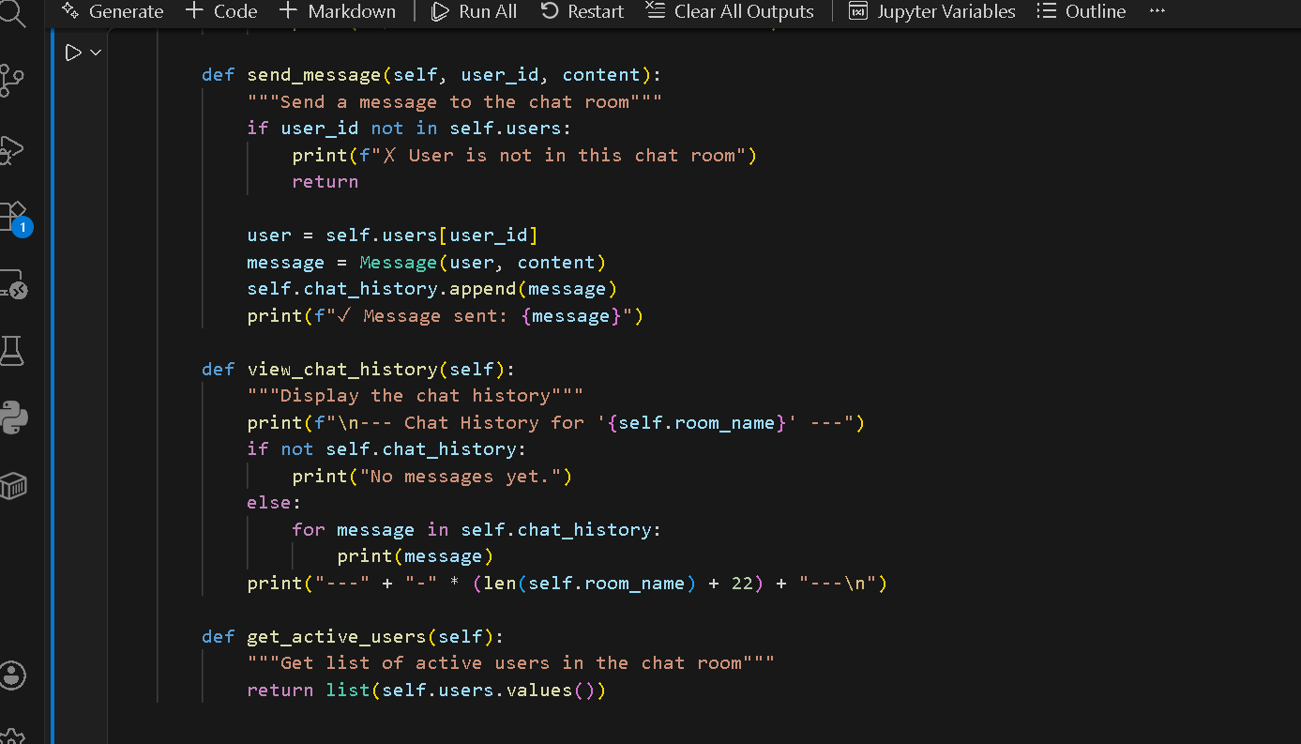

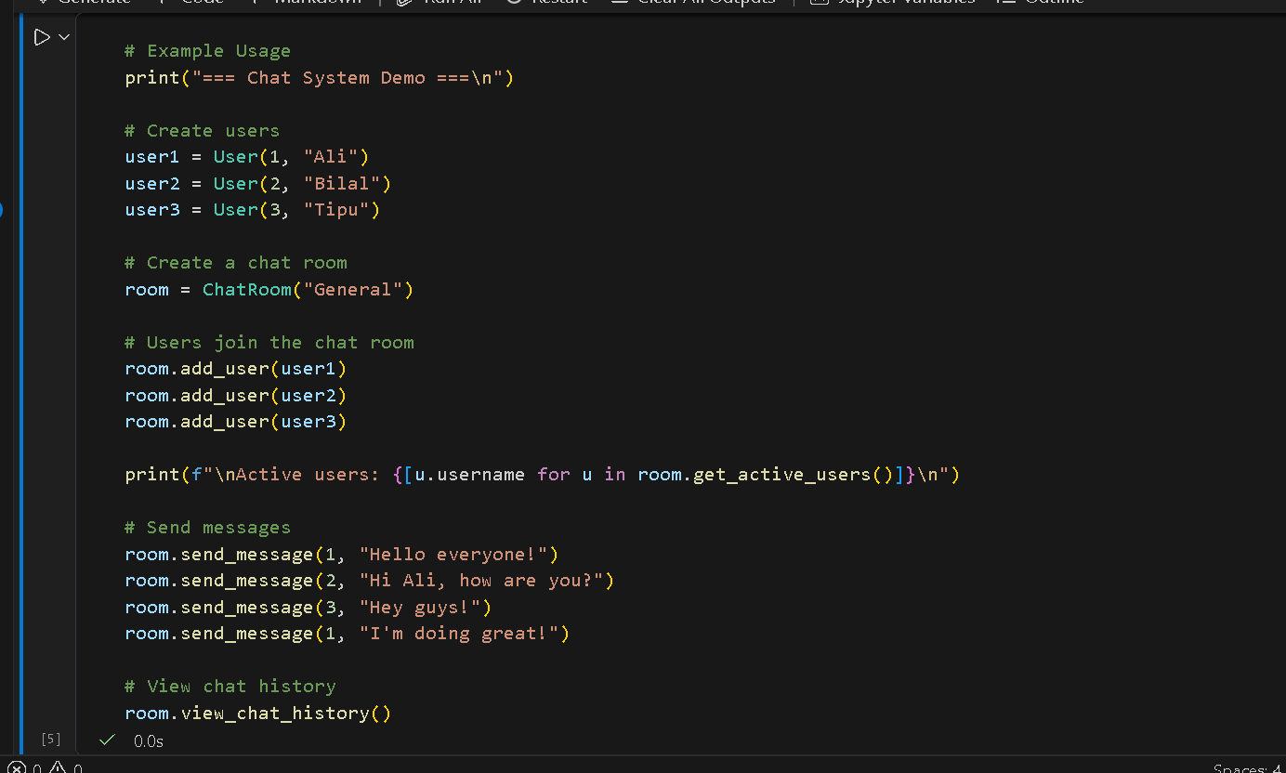

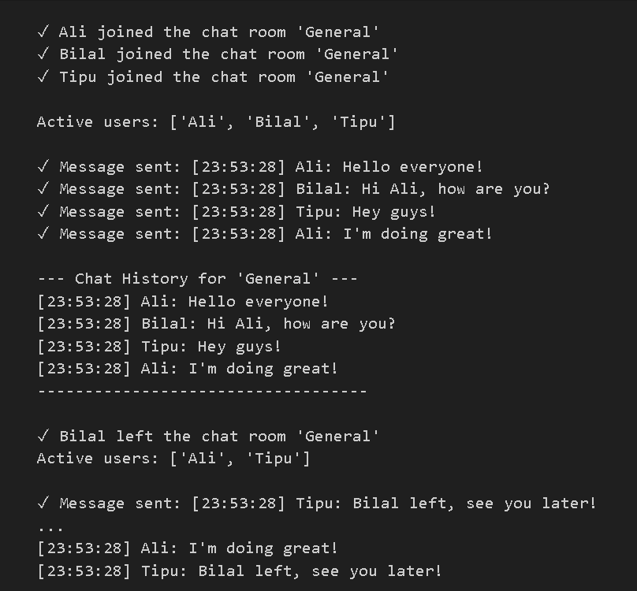

With Regards
Ehsan Afridi

